**Blood Bank Management System**

The **Blood Bank Management System** aims to simplify the management of blood donations and inventory for blood banks. It allows staff to efficiently store, retrieve, and track data related to blood donations and availability. The system's future enhancements will include features like online reservation for blood donation schedules and the ability for users to check blood availability in local blood banks during emergencies.

The system operates with three primary user roles:

* **Administrator**, who oversees system functionalities including order and payment settings.
* **Staff**, who process orders, verify payments, and manage inventory.
* **Donors**, who place orders and make payments for blood products.

**PROJECT OVERVIEW**

Introduction

Blood banks are essential for patients needing transfusions, surgery, and emergency care to ensure a sufficient and effective supply of blood. However, keeping track of employees, supplies, orders, and donor information may be difficult and time-consuming.

The Blood Bank Management System is an online tool created to oversee and manage the many blood banking procedures. The three main user roles it serves are Administrator, Employee, and Users. Admins may view orders, regulate access, manage employees, and create reports on revenue, inventory, and orders using the system. Staff may monitor blood history, change inventory, and examine and manage blood orders. Users can sign up, place blood orders, and monitor the status of their orders while getting email updates on their requests’ progress. This system makes better patient care and prompt access to blood products possible, which guarantees seamless and effective blood bank operations with real-time blood inventory updates, order management, and an intuitive user interface.

Scope and Objective

The main goal of the Blood Bank Management System is to automate the core operations of a blood bank, such as order processing, inventory tracking, donor management, and reporting. Three user roles- Admin, Staff, and Users are supported, each with a distinct task and access. Staff members take care of blood orders and inventory changes, while admins oversee employees, regulate access, and create reports. Users can track orders, request blood, and get email alerts. Using Asp.net, MVC and SQL server, the system will function as a local web application, guaranteeing smooth data administration and communication via a test email gateway.

By automating procedures, including donor communication, order administration, and inventory tracking, the Blood Bank administration system seeks to maximize blood bank operations. Through real-time updates and reporting, the system seeks to increase efficiency, accuracy, and transparency while guaranteeing prompt blood distribution and well-informed decision-making. By providing order progress updates, it also increases user involvement, which eventually raises the general effectiveness and responsiveness of blood bank services.

Modules and their Description

The system comprises 3 modules and their sub-modules as follows:

* **Admin:**
* **Login**: Admins can safely access their dashboard and control every aspect of the system by logging in.
* **Manage Staff:** Admins have the ability to assign staff responsibilities, add, edit, and remove employees, and regulate access to different system functions.
* **View Orders:** To keep track of requests and their progress, admins can filter and see blood orders by date or blood group.
* **View Donors:** To better manage the blood supply, admins can examine and filter donor data, such as blood group and donation history.
* **View Inventory:** Admins are able to track blood stock in real-time and keep an eye on the inventory levels of various blood groups.
* **Reports:** Admins have the ability to create reports with both tabular and graphical representation on orders, blood inventory, revenue, and common blood types.
* **Staff:**
* **Login:** Staff members are able to access their customized dashboard for inventory and order management by logging in.
* **Profile:** Staff have the ability to read and edit their personal profile details.
* **Change Password:** For system access, staff members can safely change the password.
* **View Orders:** Staff members are able to examine and respond appropriately to orders that are marked as Pending, Accepted, or Fulfilled.
* **Pending:** Accept or deny blood requests that are awaiting authorization.
* **Accepted:** Update the accepted orders’ status to reflect timely delivery or cancellation if necessary.
* **Fulfilled:** Orders that have been successfully fulfilled and delivered can be seen and managed.
* **Blood Inventory:** Staff members may have access to all blood group stock and track daily and monthly blood inventory movements (in and out).
* **Blood History:** With the option to filter by blood group and date, staff members can examine the inventory’s history of blood movements.
* **Blood Donation:** Staff can update the blood inventory by adding new blood donations and donor details.
* **User:**
* **Register:** Users can make an account by registering and filling out the required profile information.
* **Login:** Users who have registered can check in to track their orders and manage their accounts.
* **Profile:** Users have the ability to access and modify their profile data, including preferences and contact information.
* **Change Password:** To gain safe access to their accounts, users can modify their password.
* **Search Blood:** By choosing the blood type and needed amount, users can look for available blood. They can also select a delivery day, time, and address.
* **Orders:** Users can see whether their orders are pending, accepted, or delivered.
* **Email Notifications:** Email updates regarding orders will be sent to users and donors as soon as they are placed, accepted, or delivered.

Existing System & Proposed System

* Problem with the current scenario
* Operations at blood banks are run by hand, which results in errors, inefficiencies, and delays in order processing and inventory updates.
* It is challenging to monitor stock levels and respond to urgent demands due to the absence of real-time data on blood inventory and orders.
* Limited communication amongst contributors, users, and staff leads to disorganized order handling and delayed responses.

**PROPOSED SYSTEM**

* The goal of the proposed Blood Bank Management System is to automate and optimize several procedures related to inventory control, order fulfilment, and blood donation management.
* With specific modules for admins, staff and users, the system seeks to enhance communication and operational effectiveness within the blood bank.
* Blood orders, donor data, and inventory can all be tracked in real-time due to the admin module’s total control over staff management, access rights, and reporting.
* The Staff module makes it easier to manage orders, track inventories, and process blood donations, guaranteeing prompt and easy request fulfilment.
* With the help of the User module, blood requesters can register, place orders, and monitor the progress of their requests.
* They can also receive automated email reminders to stay updated.
* The system’s centralization of these tasks will guarantee a more responsive and effective blood bank operation, minimize human errors, and cut down on delay – all of which will enhance the standard of medical care given to patients in need.

Data Flow Diagrams (DFD’s)

A data flow diagram is a graphical tool used to describe and analyze the movement of data through a system. These are the central tools and the basis from which the other components are developed. The transformation of data from input to output, through processing, may be described logically and independently of physical components associated with the system. These are known as logical data flow diagrams. The physical data flow diagrams show the actual implementation and movement of data between people, departments and workstations. A full description of a system consists of a set of data flow diagrams. Using two familiar notations Yourdon, Gane and Sarson notation develops the data flow diagrams. Each component in a DFD is labelled with a descriptive name. The process is further identified with a number that will be used for identification purposes. The development of DFD’s is done on several levels. Each process in lower-level diagrams can be broken down into a more detailed DFD at the next level. The lop-level diagram is often called a context diagram. It consists of a single process bit, which plays a vital role in studying the current system. The process in the context level diagram is exploded into another process at the first level DFD.

The idea behind the explosion of a process into more processes is that understanding at one level of detail is exploded into greater detail at the next level. This is done until the further explosion is necessary and an adequate amount of detail is described for analysts to understand the process.

Larry Constantine first developed the DFD as a way of expressing system requirements in a graphical form, and this led to the modular design.

A DFD also known as a “bubble Chart” has the purpose of clarifying system requirements and identifying major transformations that will become programs in system design. So it is the starting point of the design to the lowest level of detail. A DFD consists of a series of bubbles joined by data flows in the system.

DFD SYMBOLS:

In the DFD, there are four symbols

1. A square defines a source(originator) or destination of system data
2. An arrow identifies data flow. It is the pipeline through which the information flows
3. A circle or a bubble represents a process that transforms incoming data flow into outgoing data flows.
4. An open rectangle is a data store, data at rest or a temporary repository of data

The process that transforms data flow. Source or Destination of data

Data flow

Data Store

CONSTRUCTING A DFD:

Several rules of thumb are used in drawing DFD’s:

1. The process should be named and numbered for easy reference. Each name should be representative of the process.
2. The direction of flow is from top to bottom and from left to right. Data traditionally flow from the source to the destination although they may flow back to the source. One way to indicate this is to draw a long flow line back to a source. An alternative way is to repeat the source symbol as a destination. Since it is used more than once in the DFD it is marked with a short diagonal.
3. When a process is exploded into lower-level details, they are numbered.
4. The names of data stores and destinations are written in capital letters. Process and dataflow names have the first letter of each word capitalized

A DFD typically shows the minimum contents of the data store. Each data store should contain all the data elements that flow in and out.

Questionnaires should contain all the data elements that flow in and out. Missing interface redundancies and like are then accounted for often through interviews.

#### SALIENT FEATURES OF DFDs

1. The DFD shows the flow of data, not of control loops and decisions are controlled considerations that do not appear on a DFD.
2. The DFD does not indicate the time factor involved in any process whether the data flows take place daily, weekly, monthly or yearly.
3. The sequence of events is not brought out on the DFD.

TYPES OF DATA FLOW DIAGRAMS

1. Current Physical
2. Current Logical
3. New Logical
4. New Physical

CURRENT PHYSICAL:

In the Current Physical DFD process labels include the names of people or their positions or the names of computer systems that might provide some of the overall system-processing labels including an identification of the technology used to process the data. Similarly, data flows and data stores are often labelled with the names of the actual physical media on which data are stored such as file folders, computer files, business forms or computer tapes.

CURRENT LOGICAL:

The physical aspects of the system are removed as much as possible so that the current system is reduced to its essence to the data and the processors that transform them regardless of actual physical form.

NEW LOGICAL:

This is exactly like a current logical model if the user were completely happy with the user was completely happy with the functionality of the current system but had problems with how it was implemented typically the new logical model will differ from the current logical model while having additional functions, absolute function removal and inefficient flows recognized.

NEW PHYSICAL:

The new physical represents only the physical implementation of the new system.

**RULES GOVERNING THE DFD’S**

PROCESS

1. No process can have only outputs.
2. No process can have only inputs. If an object has only inputs then it must be a sink.
3. A process has a verb phrase label.

**DATASTORE**

1. Data cannot move directly from one data store to another data store, a process must move data.
2. Data cannot move directly from an outside source to a data store, a process, that receives, must move data from the source and place the data into the data store
3. A data store has a noun phrase label.

**SOURCE OR SINK**

The origin and /or destination of data.

1. Data cannot move direly from a source to sink it must be moved by a process
2. A source and /or sink has a noun phrase land

DATA FLOW

1. A Data Flow has only one direction of flow between symbols. It may flow in both directions between a process and a data store to show a read before an update. The latter is usually indicated however by two separate arrows since these happen at different types.
2. A join in DFD means that the same data comes from any of two or more different processes data store or sink to a common location.
3. A data flow cannot go directly back to the same process it leads. There must be at least one other process that handles the data flow and produces some other data flow that returns the original data to the beginning process.
4. A Data flow to a data store means to update (delete or change).
5. A data Flow from a data store means to retrieve or use.

Data Flow Diagrams (DFD’s)

Blood Bank Management System DB

0.0

User

Database

DATABASE DETAIL

Query

Process

Request

1.0

User

Query

Database

Feedback For

User

Check for user

Requirement

User need

Relevant

Data

1.1

LEVEL 1 DFD

Accept

Query

2.0

User

Check Availability of or for query processing

Process

Query

Give request to user

Via Blood Bank Management System DB

Give info about DB

2.1

2.2

Query

LEVEL 2 DFD: PREDICTION

System Architecture

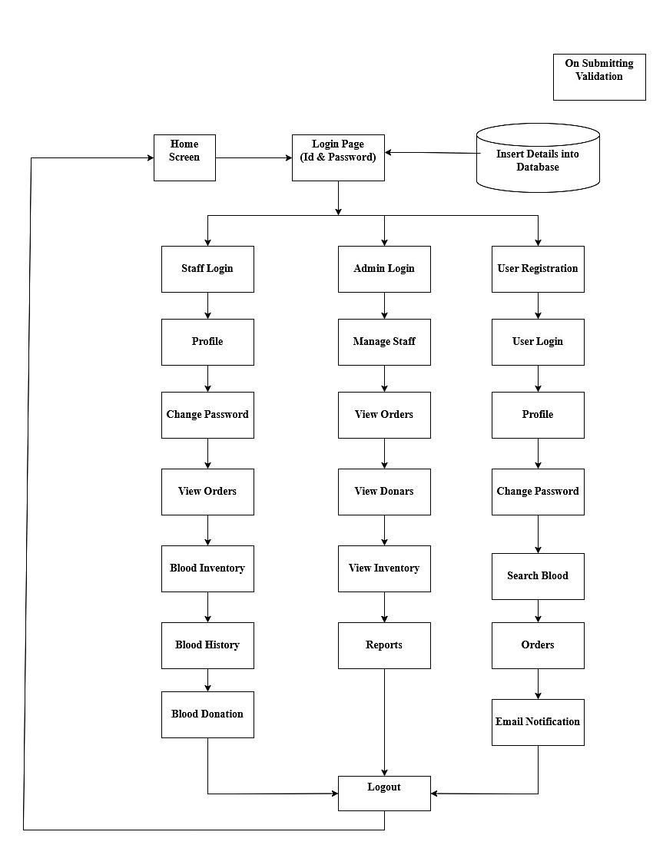Snapshots

Project Lifecycle Details

**Waterfall Model**

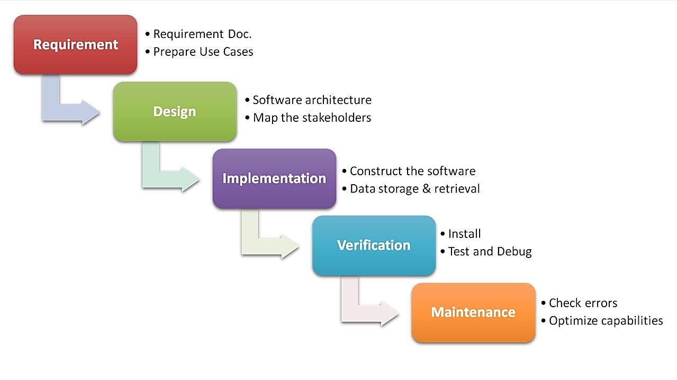

**Description**

The Waterfall Model is a linear sequential flow in which progress is seen as flowing steadily downwards (like a waterfall) through the phases of software implementation. This means that any phase in the development process begins only if the previous phase is complete. The waterfall approach does not define the process of going back to the previous phase to handle requirement changes. The waterfall approach is the earliest approach that was used for software development.

**PROJECT DESIGN**

E-R Diagram

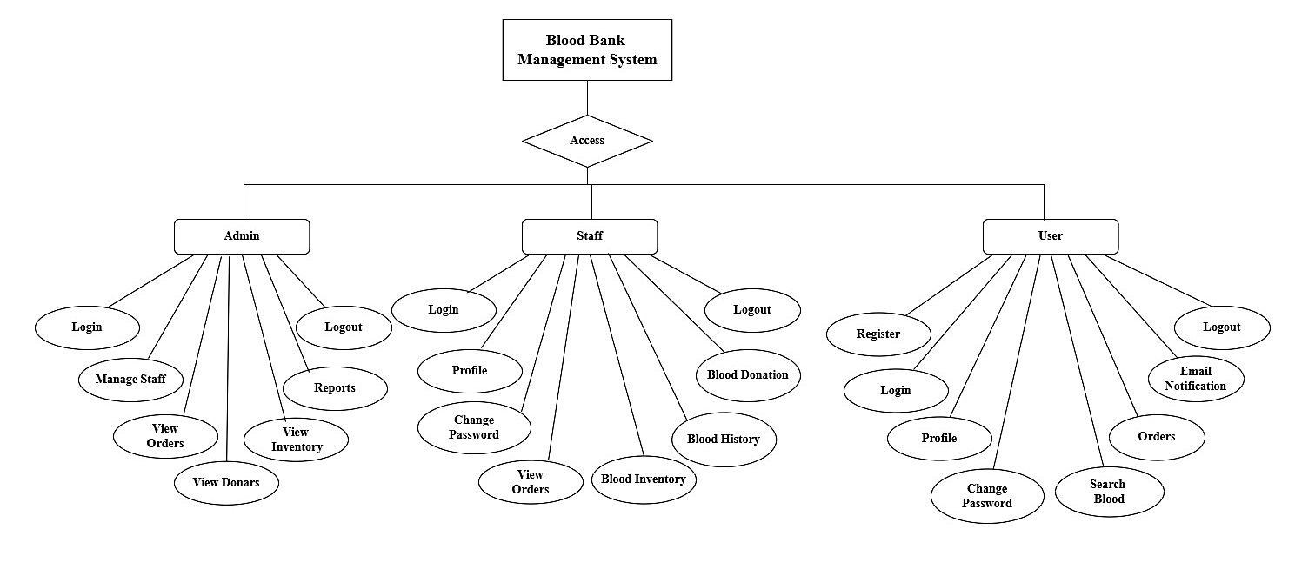

**Requirement Diag:**

Use Case Diagram:

Admin:

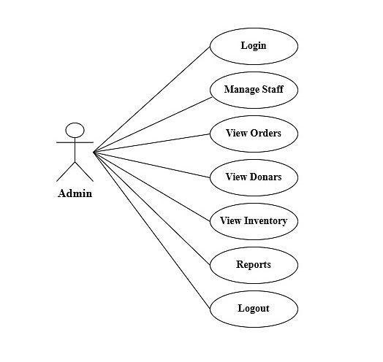

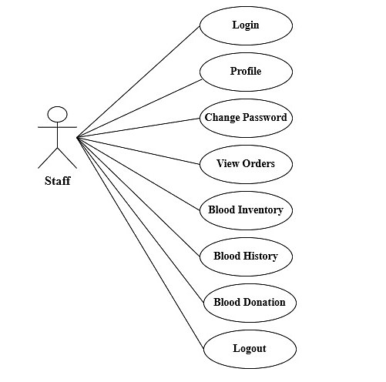

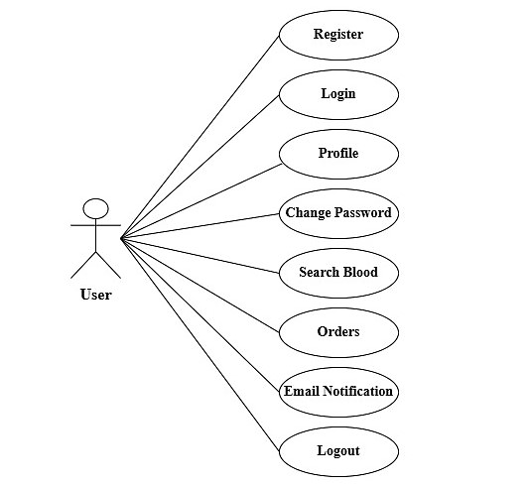

**Donor**

Activity Diagram:

Admin:

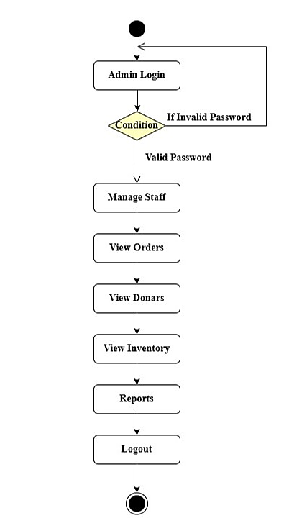

Staff:

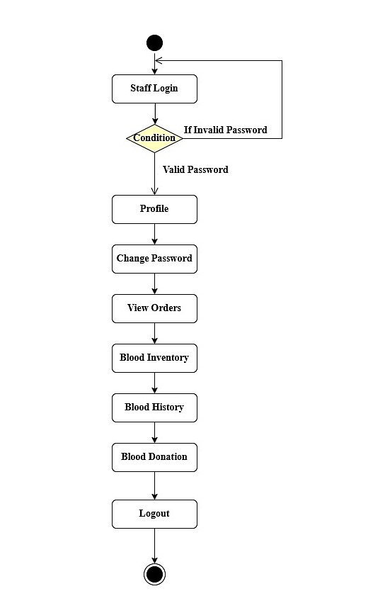

User:

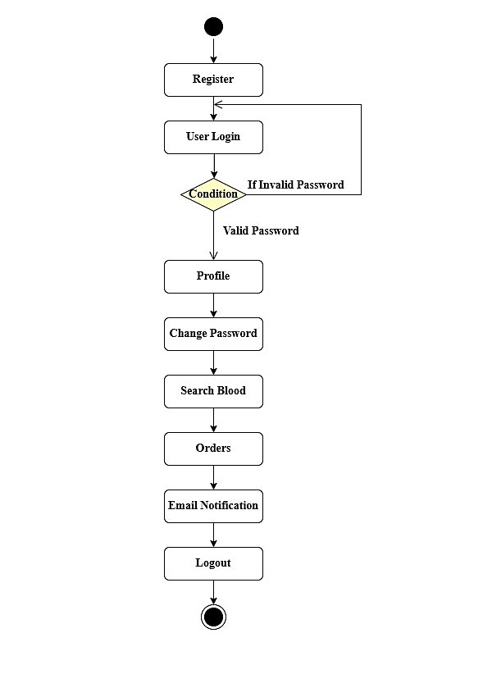

**Class Diagram:**

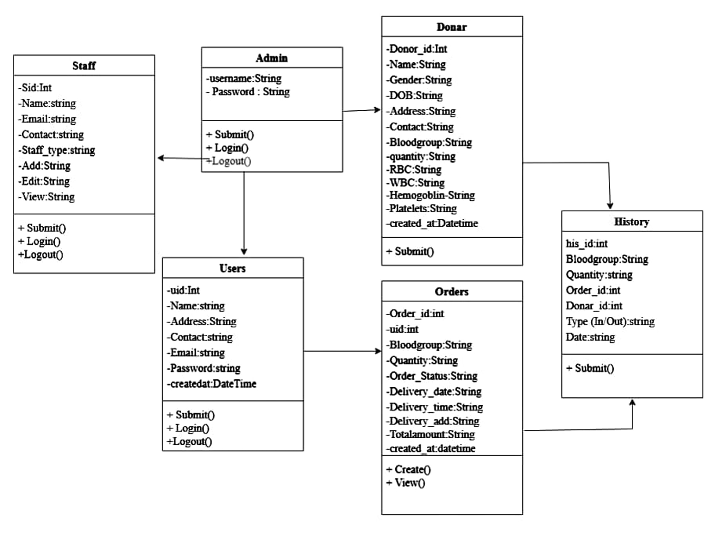

Project Implementation Technology

The Project is designed and developed in Visual Studio. We used Visual Studio for the coding of the project. Created and maintained all databases in SQL Server, in that we create tables, and write queries for store data or records of project.

***Technologies & Tools***

* **Operating System**: Windows latest verion
* **Languages**: ASP.NET MVC with C#
* **Database System**: MS-SQL/SQL Server using Entity Framework (ORM)
* **IDE**: Visual Studio 2022 & SSMS 2019

**User:**

* **Role:**
  + Primarily refers to individuals who request blood from the system (e.g., patients or their representatives).
  + Their focus is on accessing the services provided by the blood bank.
* **Responsibilities:**
  + **Registration and Login:** Users create an account and log in to manage their profiles and activities.
  + **Search Blood:** They can check for the availability of specific blood types in the system.
  + **Place Orders:** Users can request blood, specifying details such as type, amount, and delivery information.
  + **Track Orders:** They can monitor the status of their requests (Pending, Accepted, Delivered).
  + **Notifications:** Receive email updates on the status of their orders.
  + **Profile Management:** Update personal information like name, contact details, and password.
* **Purpose:**
  + Simplifies the process of finding and requesting blood during emergencies or regular medical needs.
  + Allows for real-time updates on the availability of blood.

**Donor:**

* **Role:**
  + Refers to individuals who donate blood to the system to maintain the inventory.
  + Their focus is on contributing to the blood bank's supply.
* **Responsibilities:**
  + **Blood Donation:** Donors visit blood banks to donate blood.
  + **Record Updates:** Their donation details, such as blood group, donation date, and history, are recorded in the system.
  + **Support Inventory Management:** Their donations contribute to maintaining stock levels in the blood bank.
* **Purpose:**
  + Helps the system maintain a sufficient blood supply to meet demands.

**Staff:**

* + **Role:**
  + Staff members are the operational backbone of the blood bank.
  + They handle the day-to-day activities related to inventory, orders, and donor management.
  + **Responsibilities:**
  + **Login and Profile Management:**
  + Access their personalized dashboard to manage tasks and update profile details securely.
  + **Order Management:**
  + View, process, and update blood orders with statuses:
  + **Pending:** Accept or reject new requests.
  + **Accepted:** Ensure timely delivery or manage cancellations if necessary.
  + **Fulfilled:** Maintain records of successfully completed orders.
  + **Inventory Management:**
  + Monitor blood stock levels for all blood groups in real-time.
  + Track daily and monthly blood movements (in and out).
  + Update inventory after receiving blood donations.
  + **Blood Donation Management:**
  + Add new donor details and update the inventory with their blood donations.
  + **Blood History Tracking:**
  + Maintain records of blood inventory changes with options to filter by blood group or date.
  + **Purpose:**
  + Ensure smooth operations by maintaining accurate records of inventory and order fulfillment.
  + Act as the bridge between donors, users, and the admin by handling operational-level tasks.

**Admin:**

* + **Role:**
  + The admin oversees and manages the entire system, ensuring all modules (Users, Donors, Staff, Inventory, and Orders) function effectively.
  + They hold the highest level of authority in the system.
  + **Responsibilities:**
  + **Login and Access Control:**
  + Safely access the system and manage all features from a centralized dashboard.
  + Assign roles and regulate access permissions for staff.
  + **Manage Staff:**
  + Add, edit, and remove employees from the system.
  + Define responsibilities and monitor their activities.
  + **Order Monitoring:**
  + View and track blood orders based on parameters like blood group, order status, and date.
  + **Donor Management:**
  + Access donor data, including blood groups and donation history, for effective supply chain planning.
  + **Inventory Oversight:**
  + Track real-time stock levels for all blood groups.
  + Ensure a balanced inventory to avoid shortages or wastage.
  + **Generate Reports:**
  + Create detailed reports in tabular and graphical formats on:
  + Orders (pending, fulfilled, or canceled).
  + Blood inventory trends (levels and movements).
  + Revenue generated.
  + Commonly requested blood types.
  + **System Control:**
  + Regulate the overall functionality of the system, ensuring smooth and error-free operations.
  + **Purpose:**
  + Maintain overall governance of the blood bank system by ensuring the system’s efficiency and accuracy.
  + Provide insights and strategic decisions through reporting and data analysis.
  + Act as the authority figure to resolve issues and ensure compliance with operational guidelines.

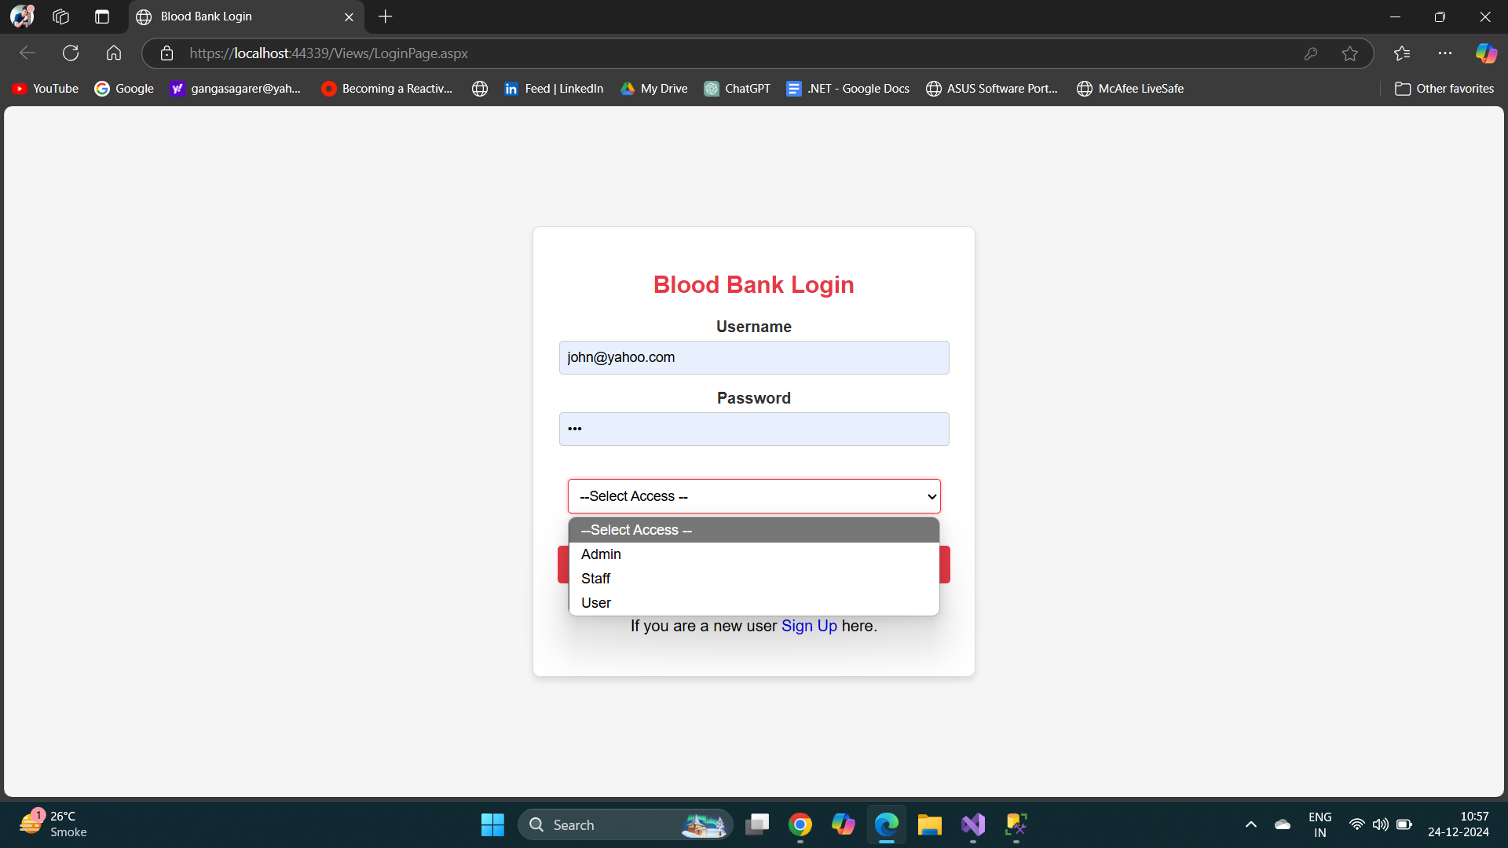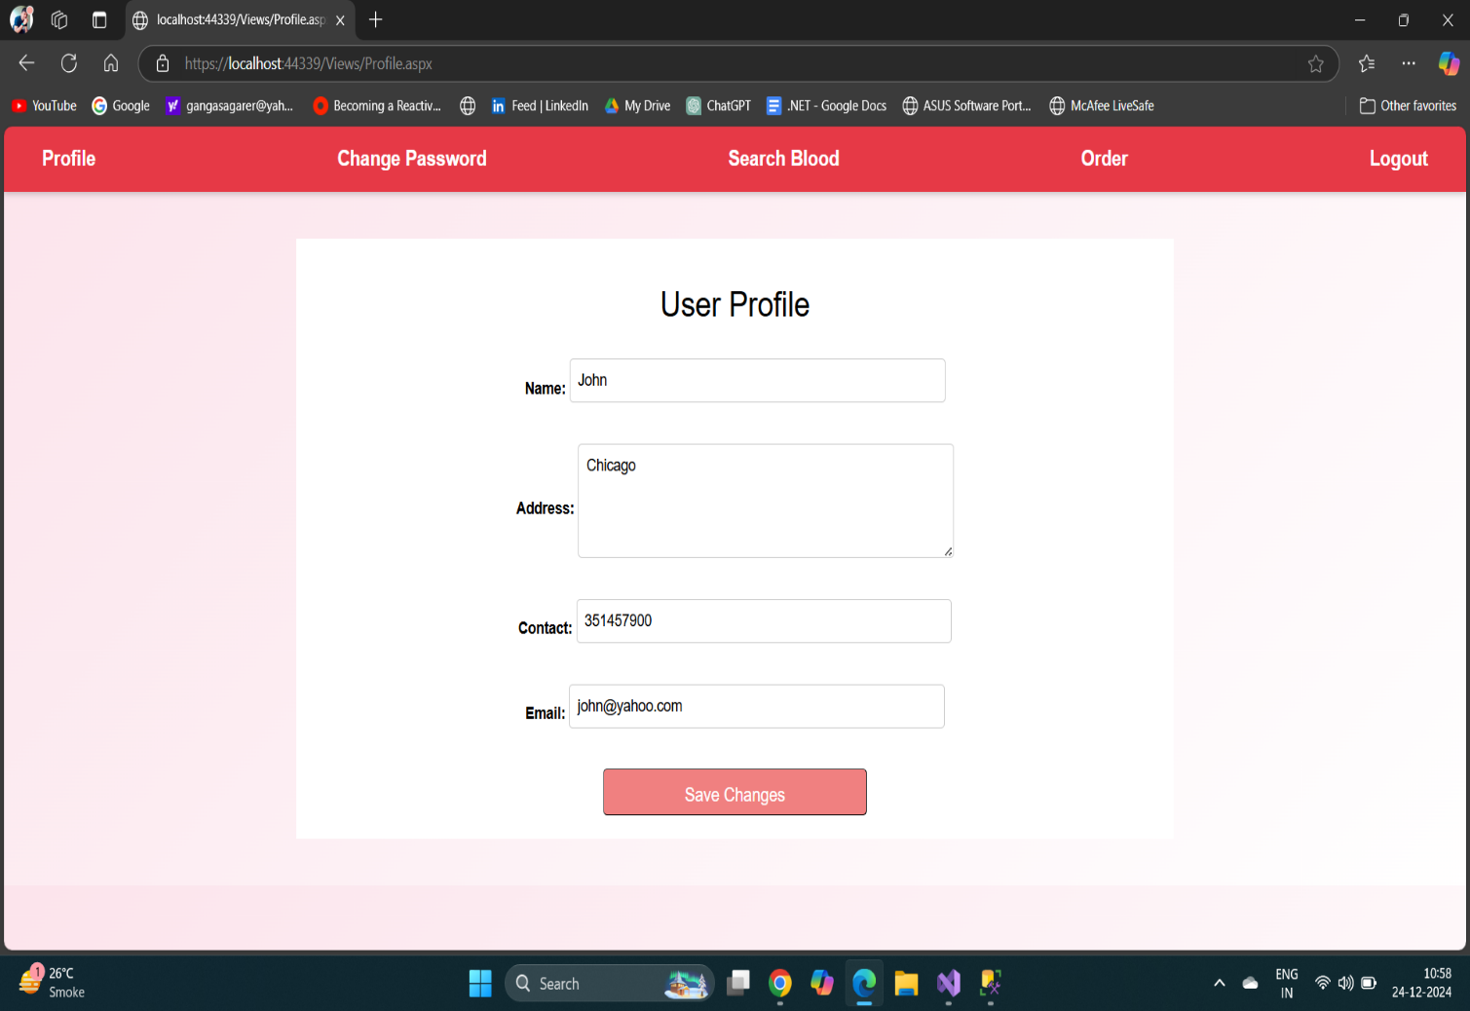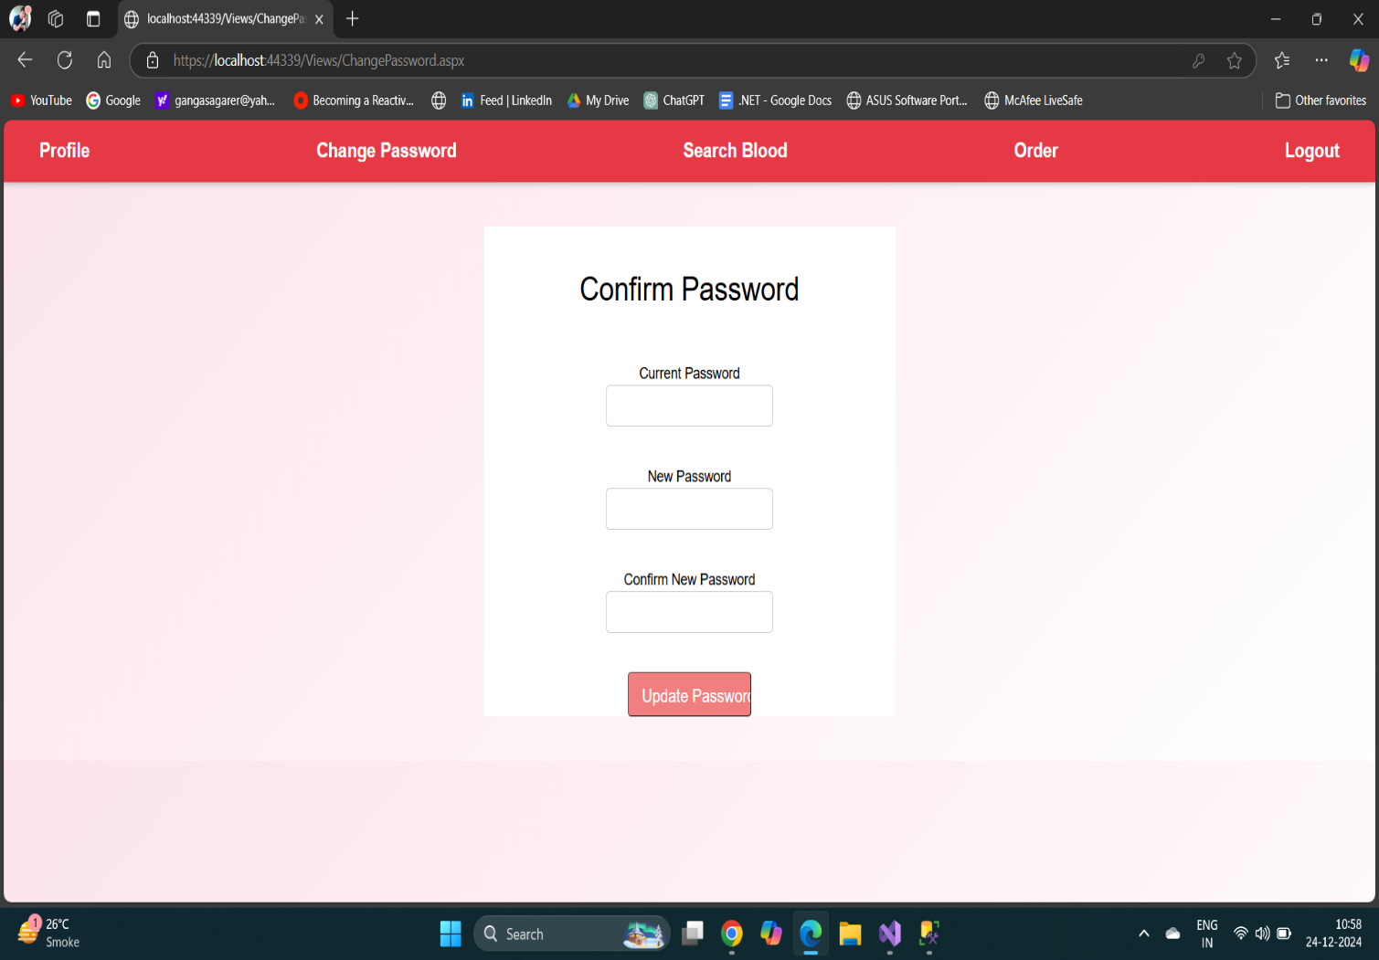

**Login Page & User Profile:**

**Change & Update Password**

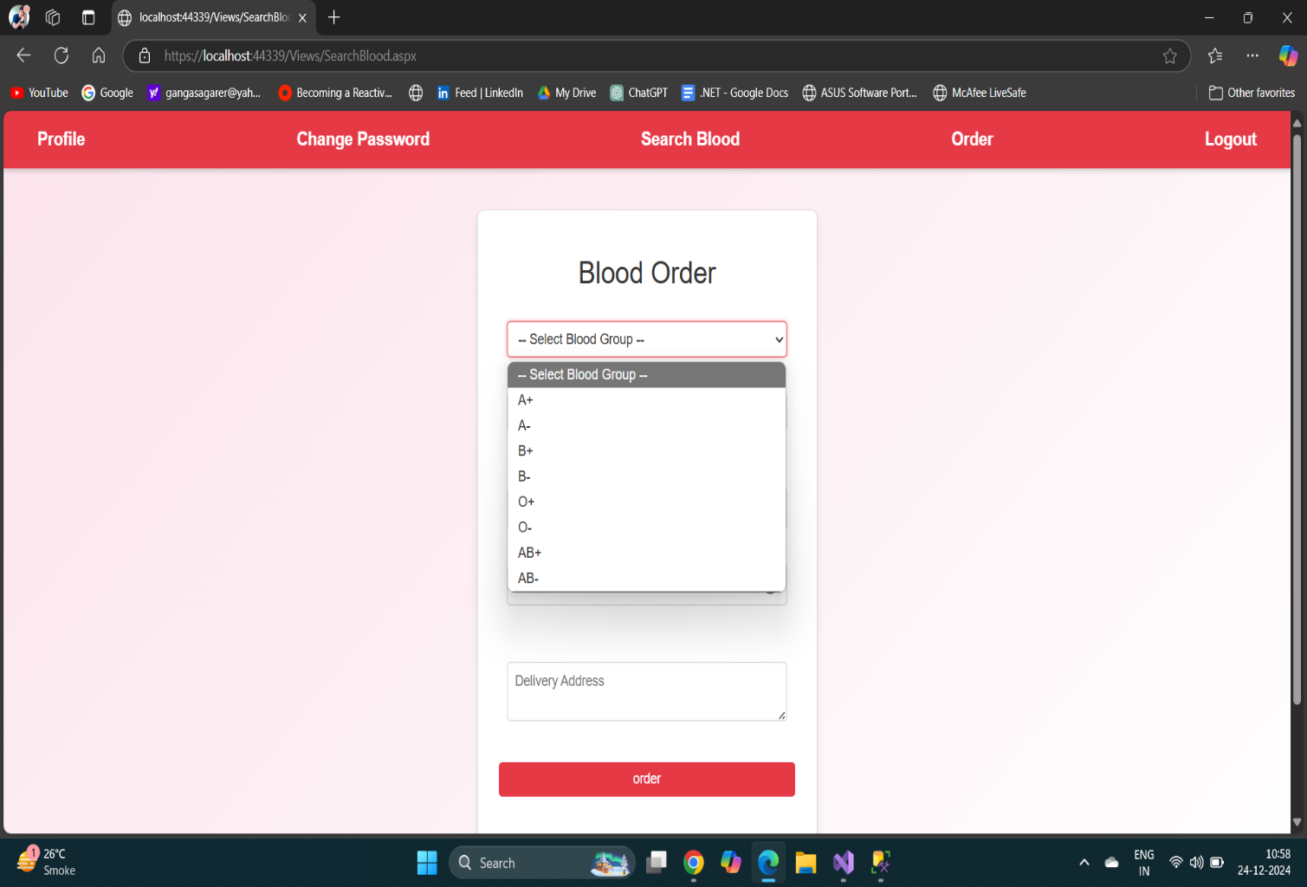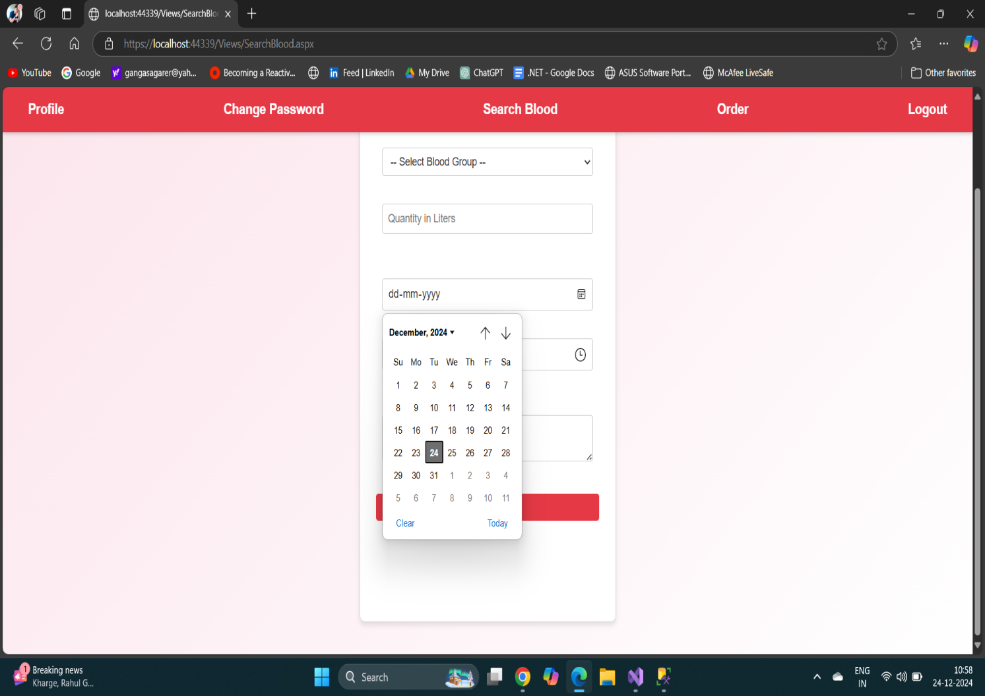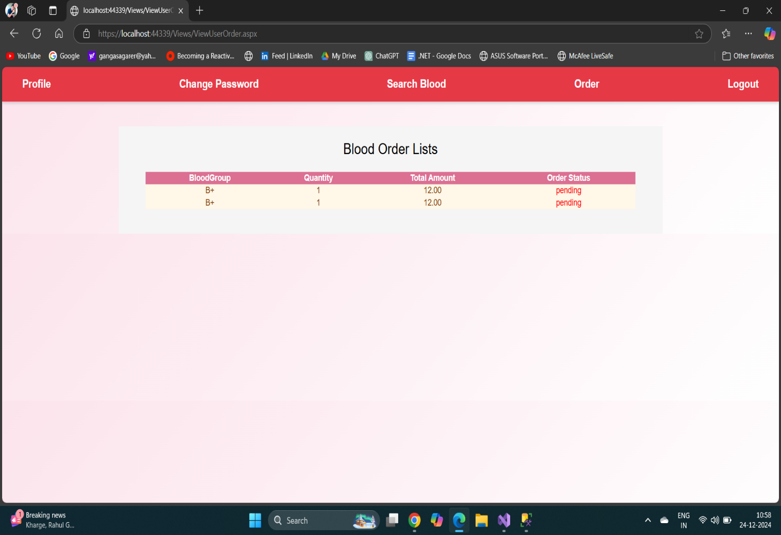

**Blood Group & Date Time select for order**

**Blood order list**